C:\Users\William\AppData\Local\Microsoft\Windows\Temporary Internet Files\Content.IE5\YY1DNRXP\MC900216576[1].wmfC:\Users\William\AppData\Local\Microsoft\Windows\Temporary Internet Files\Content.IE5\QOOR3TNG\MC900149513[1].wmf

The Civil War began in **1861**.

Abraham Lincoln died on **April 15, 1865**.

April 15, 1865

Abraham Lincoln was born on **February 12, 1809**.

1863

April 9, 1865

Timeline of **Abraham Lincoln’s** Life

He ended slavery in **1863**.

The Civil War ended on **April 9, 1865**.

Abraham Lincoln became our 16th president in **1860**.

1861

1860

Glue next page here.

Glue next page here.

Glue next page here.

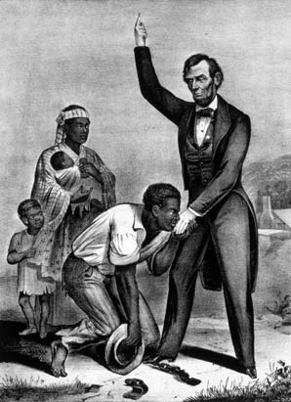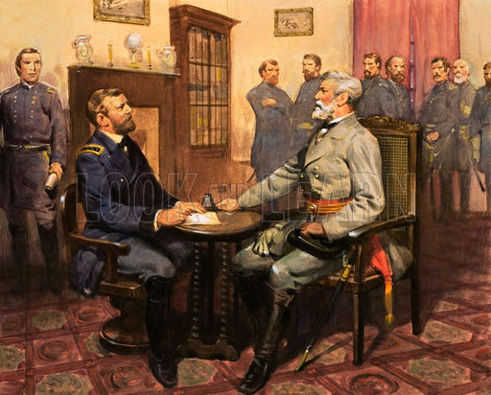C:\Users\William\AppData\Local\Microsoft\Windows\Temporary Internet Files\Content.IE5\AZW9AVDJ\MC900014616[1].wmf

February 12, 1809